**STAR GPT**

**A Main Project Report**

Submitted to the **FACULTY** of **ENGINEERING** of

**A.A.N.M & V.V.R.S.R POLYTECHNIC, GUDLAVALLERU.**

In partial fulfillment of the requirements, for the

award of the

**DIPLOMA**

In

**Department of computer engineering**

By

**Team Leader**

**K.Sandeep**

(21030-cm-136)

Under the Guidance of

**A.Krishna chaitanya**

Associate Professor

**Department of Computer Engineering**

**A.A.N.M & V.V.R.S.R POLYTECHNIC**

**Department of Computer Engineering**

**A.A.N.M & V.V.R.S.R POLYTECHNIC**

(Private college under the control of state broad of technical education and training)

SESHADRIRAO KNOWLEDGE VILLAGE

GUDLVALLERU -52135



CERTIFICATE

This is to certify that the project report entitled **"STAR GPT"** is bonafide record of work carried out by **K.Phani Sri Ram** (21030-cm-137),**K.Sandeep** (21030-cm-136),**K.Jagadeesh** (21030-cm-161),**K.pranesh** (21030-cm162),

**G.Sravan** (21030-cm-133),**M.Prem** (21030-cm-188) Under my guidance and supervision in partial fulfillment of the requirements, for the award of the **DIPLOMA** in **Department of computer engineering** by **A.A.N.M &V.V.R.S.R POLYTECHNIC , GUDLAVALLERU.**

**Acknowledge**

(A.Krishna chaitanya)

**Project supervisor**

(A.Krishna chaitanya)

**Head of the Department**

We are very glad to express our deep sense of gratitude to Sir **A.Krishna chaitanya,** Associate Professor, Department of Computer Engineering, for the guidance and cooperation for completing this project. We convey our heartfelt thanks to him for his inspiring assistance till the end of our project.

We convey our sincere and indebted thanks to our beloved Head of the Department **A.Krishna chaitanya** for his encouragement and help for completing our project successfully.

We also extend our gratitude to our Principal **Dr.N.Rajasekhar**, for the support and for providing facilities required for the completion of our project.

We impart our heartfelt gratitude to all the Lab Technicians for helping us in all aspects related to our project.

We thank our friends and all others who rendered their help directly and indirectly to complete our project.

**PROJECT MEMBERS :-**

K.Phani Sri Ram (21030-cm-137)

K.Sandeep (21030-cm-136)

K.pranesh (21030-cm-162)

K.Jagadeesh (21030-cm-161)

G.Sravan (21030-cm-133)

M.prem(21030-cm-188)

**Content**

|  |  |  |
| --- | --- | --- |
| S.No | TITLE | **PAGE NO**  **(1 to 5)** |
|  | List of the figures | 6 |
|  | Abstract | **7** |
| **1** | **Introduction** | 8 |
| **2** | **System Requirements** | **9** |
|  | 1. openai |
|  | 1. PyQt5 |
|  | 1. requests |
|  | 1. Pillow |
|  | 1. Google Text to Speech (gtts) |
| **3** | **User Interface Overview** | **10** |
|  | 1. Theme Selection Buttons | **11** |
|  | 1. Prompt and Language Input |
|  | 1. Action Buttons |
|  | 1. Generate Code |
|  | 1. Generate Content |
|  | 1. Generate Image |
|  | 1. Text-to-Speech | **12-13** |
|  | 1. Continue Generating Code |
|  | 1. Continue Generating Content |
|  | 1. Help |
|  | 1. Report or Message |
|  | 1. Open in web |
|  | 1. Download apk |
|  | 1. Exit | **14** |
| **4** | **Task Specifics** | **14-15** |
|  | * Create chatbot to this application |
|  | 1. Generate Code and Content |
|  | 1. Generate Image | 16-17 |
|  | 1. Text-to-Speech |
|  | 1. Continue Generating Code/Content |
|  | 1. Open in web |
|  | 1. Download apk |
|  | 1. Help and Report |
| **5** | **Customization and Theming** | **14-15** |
| **6** | **Troubleshooting** | **15** |
| **7** | **Disclaimer** | **15-16** |
| **8** | **Conclusion** | **16** |

**List of the figures**

|  |  |  |
| --- | --- | --- |
| **S.No** | **Figures name** | **Page no** |
| 1 | Desktop view | **8** |
| **2** | Main Components | **10** |
| 3 | Application view | **13** |

**Abstract**

The STAR GPT is a desktop tool that integrates various artificial intelligence (AI) functionalities, including generating code, content, images, and converting text to speech. It uses the OpenAI API and has a user-friendly graphical interface built with PyQt5. To run the application, users need Python 3.x installed on their system and several required Python packages, including Openai, PyQt5, Requests, Pillow, and gtts. The application also offers customization options for theming and troubleshooting support. The report includes a list of figures and acknowledgments to those who contributed to the project's completion**STAR GPT**

1. **Introduction**

The STAR GPT is a versatile tool that allows users to perform various AI-related tasks, such as generating code, content, images, and even converting text to speech. It leverages the OpenAI API to provide these functionalities and provides a user-friendly graphical interface built with PyQt5.

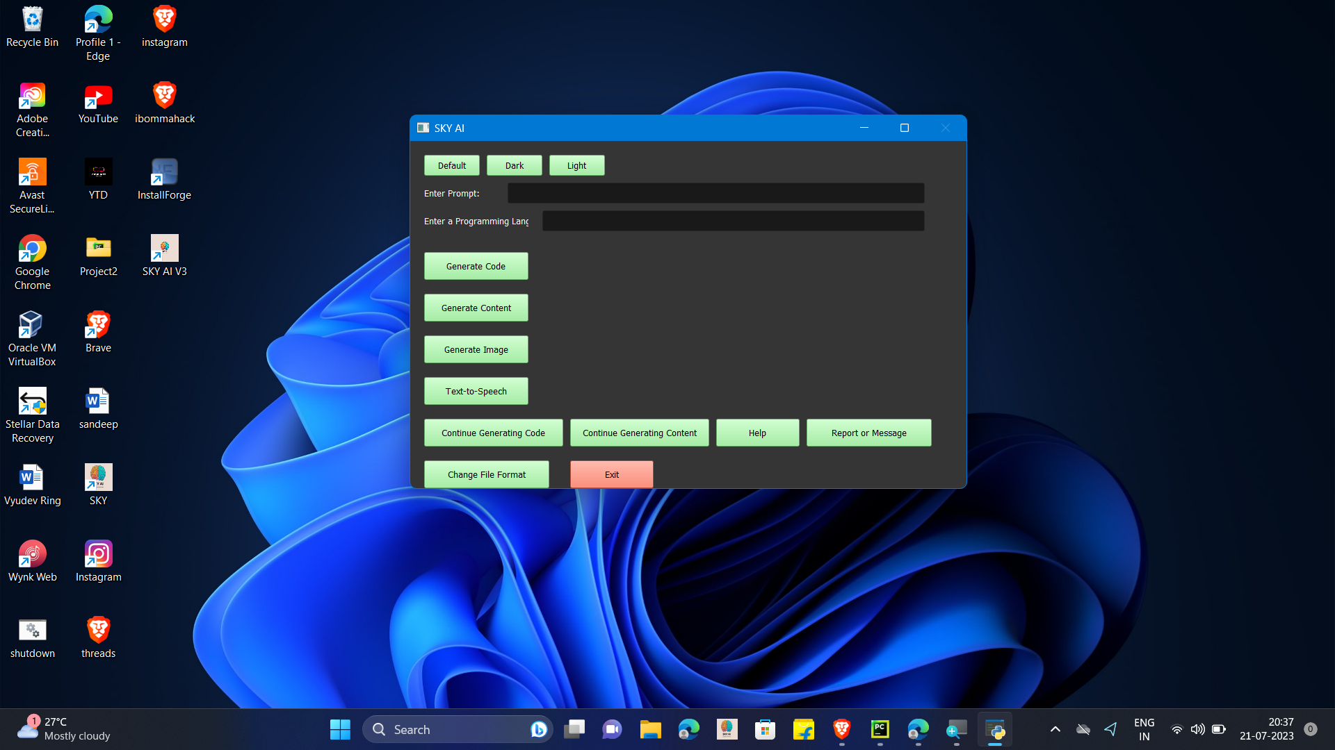

**Fig 1:- desktop view**

2.**System Requirements**

To run the STAR GPT, you need the following:

Python 3.x installed on your system.

Required Python packages,which you can using pip install.

1. **Openai:** To interact with the OpenAI API for code,

content, and image generation.

1. **PyQt5**: To create the graphical user interface.
2. **Requests**: To handle HTTP requests for downloading

images.

1. **Pillow**: To work with images in Python.
2. **gtts**: For text-to-speech conversion.

**Setup and Installation**

* Download the STAR GPT from the Cloud
* Install the required Python packages using pip. Run the following command in your terminal or command prompt:

pip install openai PyQt5 requests Pillow gtts

**Usage**

To run the STAR GPT , execute the following command in your terminal or command prompt:

python star_gpt.py

Upon running the command, the STAR GPT graphical user interface will open, and you will see various options to perform different AI tasks.

**3.User Interface Overview**

The STAR GPT has a user-friendly graphical user interface (GUI) with the following main components:

**Fig 2**: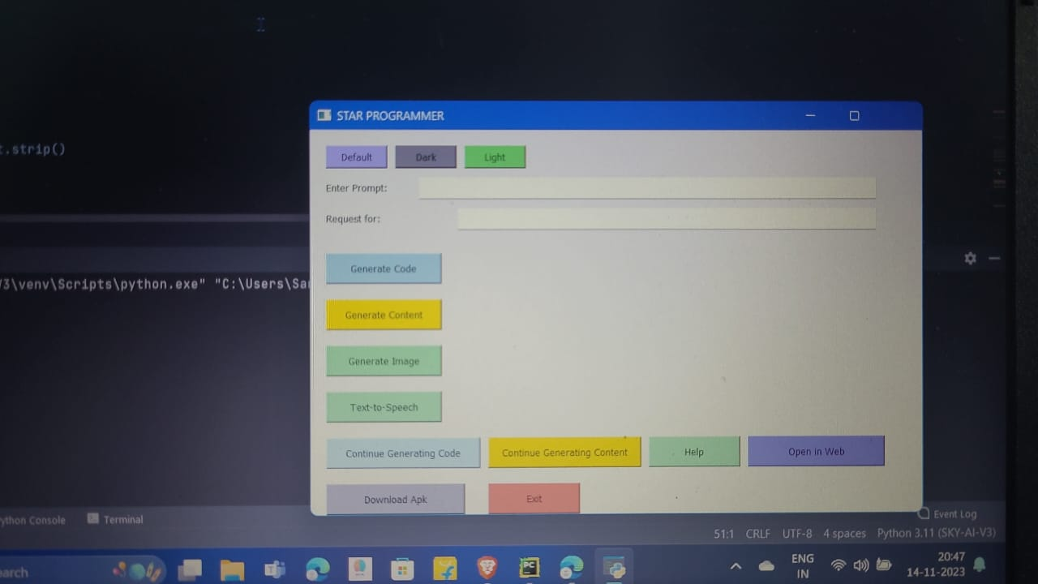- Desktop Application Main Components1.**Theme Selection Buttons** :

The application provides three themes - Default, Dark, and Light. You can choose your preferred theme by clicking on the corresponding theme button.

1. **Prompt and Language Input** :

The user can enter the task prompt in the "Enter Prompt" field and specify the programming language or any other information in the "Enter a Programming Language or anything" field.

**3.Action Buttons**:

The application provides several

action buttons to perform different AI tasks:

4.**Generate Code**:

Click this button to generate cod

based on the entered prompt and language.

**5.Generate Content:**

Click this button to generate content

based on the entered prompt and language.

**6.Generate Image**:

Click this button to generate an

image based on the entered prompt.

7.**Text-to-Speech**:

Click this button to convert the

entered prompt text into speech.

**8.Continue Generating Code**:

Click this button to continue

generating more code without entering

new prompt.

9.**Continue Generating Content**:

Click this button to continue

generating more content without entering

a new prompt.

**10.Help**:

Click this button to open the URL with

information or help about the application.

11.**Report or Message**:

Click this button to open the URL for

contacting the developer or providing

feedback.

12.**Change File Format**:

Click this button to change the

format of the generated file.

13. **Download apk :-**

Click this button to install the Android

application file (APK) on your device**.**

**14. Open i**n web :-

To open an application in a web page

or website, click this button.

1. **Exit**:

Click this button to exit the application. A confirmation prompt will appear before exiting.

**4.Task Specifics**

**Create chatbot to this application**

Using an API key to generate your own chat application entails integrating with a natural language processing (NLP) API, such as OpenAI's GPT-based API. Here's a quick overview:

1. **receive an API Key**: Sign up for OpenAI API access and receive an API key.

2.**Understand API Documentation**: - Read the API documentation supplied by OpenAI to learn how to make requests and handle responses.

3. **Create Your Development Environment**: Create a development environment in your preferred programming language (Python is usually used for this).

4. **Install Required Libraries**: Install any libraries required to make HTTP queries. You might use Python's'requests' package.

**5. Make API calls**: Using your API key, make OpenAI API calls, passing the user's input to get model-generated responses.

6. **manage Responses**: In your application, extract and manage the model-generated answer from the API response. You may need to process or filter the response based on the needs of your application.

7. **User Interface Integration**: Integrate the chat capability into the user interface of your application. Capturing user input, submitting it to the API, and presenting the model-generated result are all part of this process.

8. **Error Handling**: Use error handling to handle scenarios in which the API request fails or produces unexpected results.

9. Testing: Ensure that your application performs as expected by extensively testing it in a variety of settings.

10**. Security Considerations**: Ensure safe API key management and adhere to recommended practices for user data privacy.

**1.Generate Code and Content**:

Enter a prompt and a programming language or any other information in the designated input fields. Click the "Generate Code" button to generate code or "Generate Content" button to generate content based on the provided prompt and language. The generated code or content will be displayed in a Notepad window, and the user will be notified about the success of the operation.

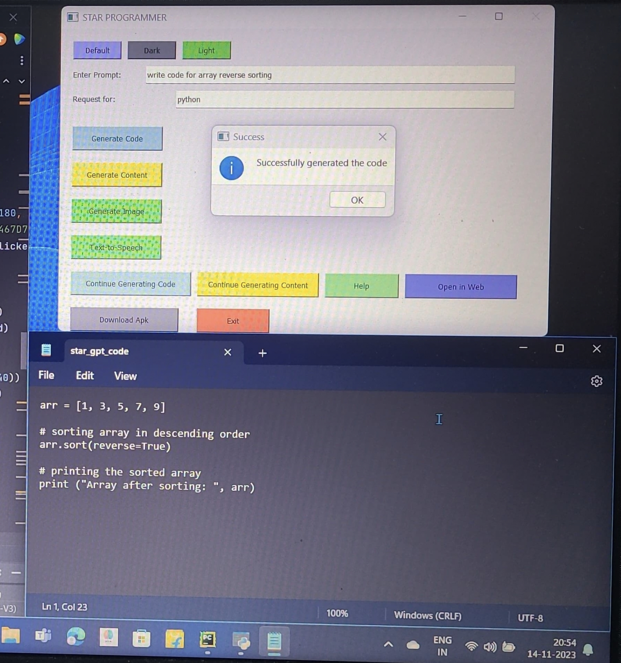

Fig :- APPLICATION VIEW

2.**Generate Image**:

Enter a prompt that describes the image you want to generate. Click the "Generate Image" button to generate an image based on the entered prompt. The image will be displayed in a window, and the user can save the image to their device.

3.**Text-to-Speech**:

Enter the text you want to convert to speech in the prompt field. Click the "Text-to-Speech" button, and the application will generate an audio file and play it.

4.**Continue Generating Code/Content**:

These buttons allow the user to generate more code or content without entering a new prompt. The user only needs to provide the programming language or any other information.

5.**Downlaod apk :-**

Click this button to install the Android

application file (APK) on your device.

**6.Open in web:-**

To open an application in a web page or

website, click this button.

5.**Help and Report**:

These buttons open URL's with useful information, help, or contact details for reporting issues or providing feedback.

5.**Customization and Theming**

The application provides three themes - Default, Dark, and Light. Users can choose their preferred theme by clicking on the corresponding theme button. Additionally, the application allows customization using a custom style sheet. You can modify the set_style method in the Main Window class in the code to apply your desired custom styles to the application.

**6.Troubleshooting :**

If the application encounters any errors while generating code, content, or images, an error message will be displayed to the user. If you face any issues with the application, ensure that you have a stable internet connection and a valid OpenAI API key. Also, verify that you have correctly installed all the required Python packages and dependencies.

**7.Disclaimer :**

The STAR GPT relies on the OpenAI API for generating code, content, and images. The actual results may vary depending on the prompt and other factors. The application is provided as-is, and the developer does not guarantee the accuracy or suitability of the generated outputs for any specific use case. Use the application responsibly and at your own risk.

1. **conclusion :**

The STAR GPT is a desktop tool that integrates various artificial intelligence (AI) functionalities, including generating code, content, images, and converting text to speech. It uses the OpenAI API and has a user-friendly graphical interface built with PyQt5. To run the application, users need Python 3.x installed on their system and several required Python packages, including Openai, PyQt5, Requests, Pillow, and gtts. The application also offers customization options for theming and troubleshooting support. The report includes a list of figures and acknowledgments to those who contributed to the project's completion**.**

Links for Web Application and Android APK:

1. [Web Application](https://star-programmer.vercel.app)
2. Android APK